Principles of javascript

Thread of execution

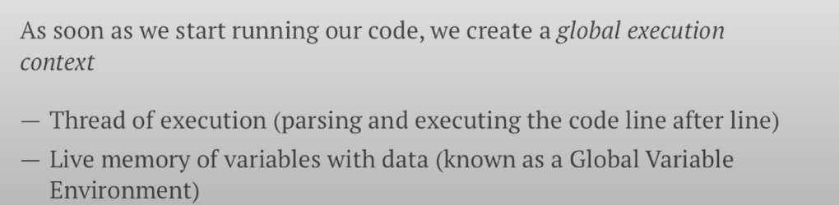

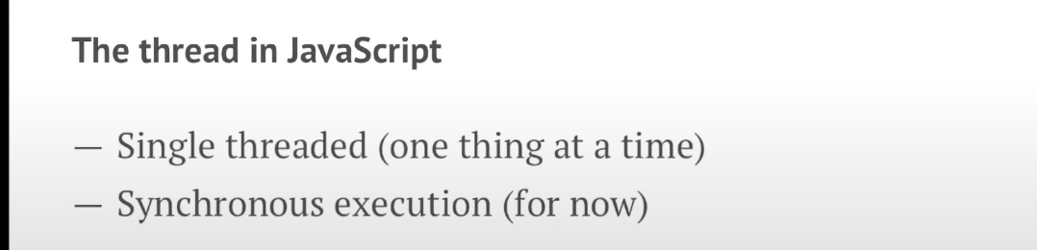

Global memory or global variable environment = saves our variables and functions

Global execution context comprising our thread of execution line by line execution code.

When we call/run/ or invoke a function we create something called:

Local execution context:

It has Local Memory:

First thing = Input number

Second thing = The value of result

Third thing = it ends with the return

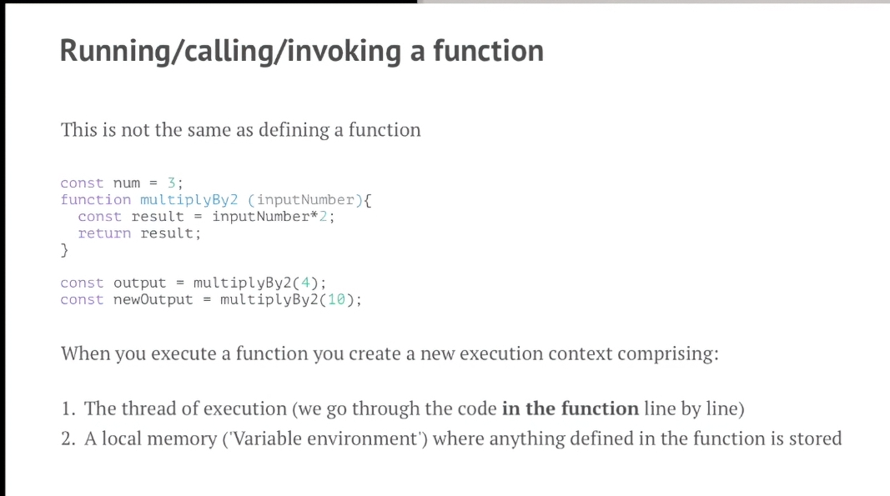

Call stack

Tracks our execution contexts

FILO = First In Last Out

Our first in our stack is the Global Context

Then every local execution contexts (functions)

Once our function is done then it pops off our call stack

Opposite is push on our call stack

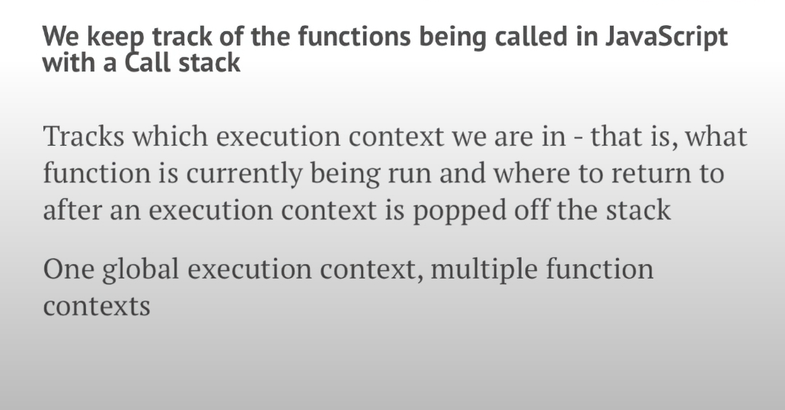

Objects

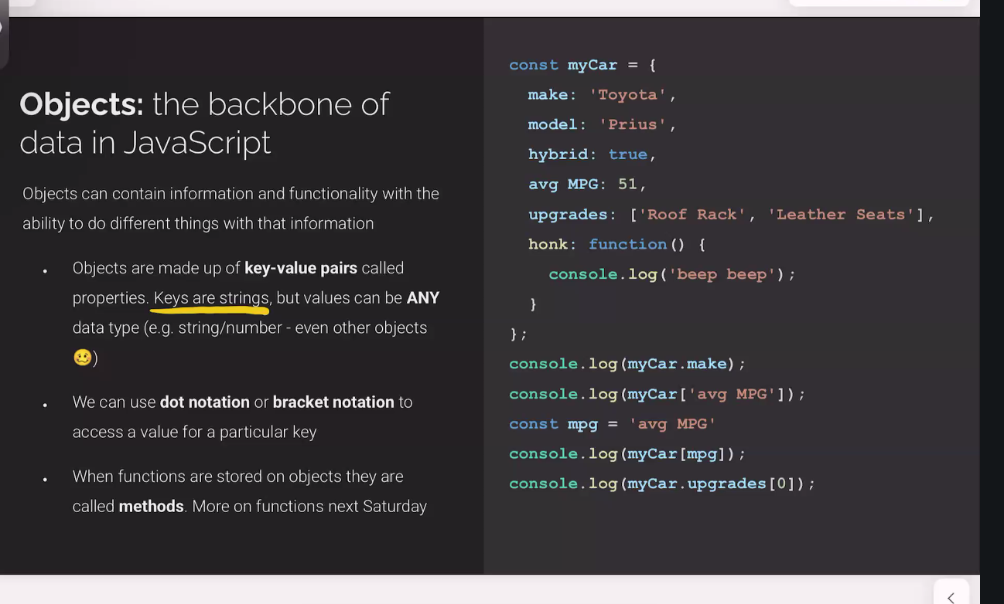

Functions

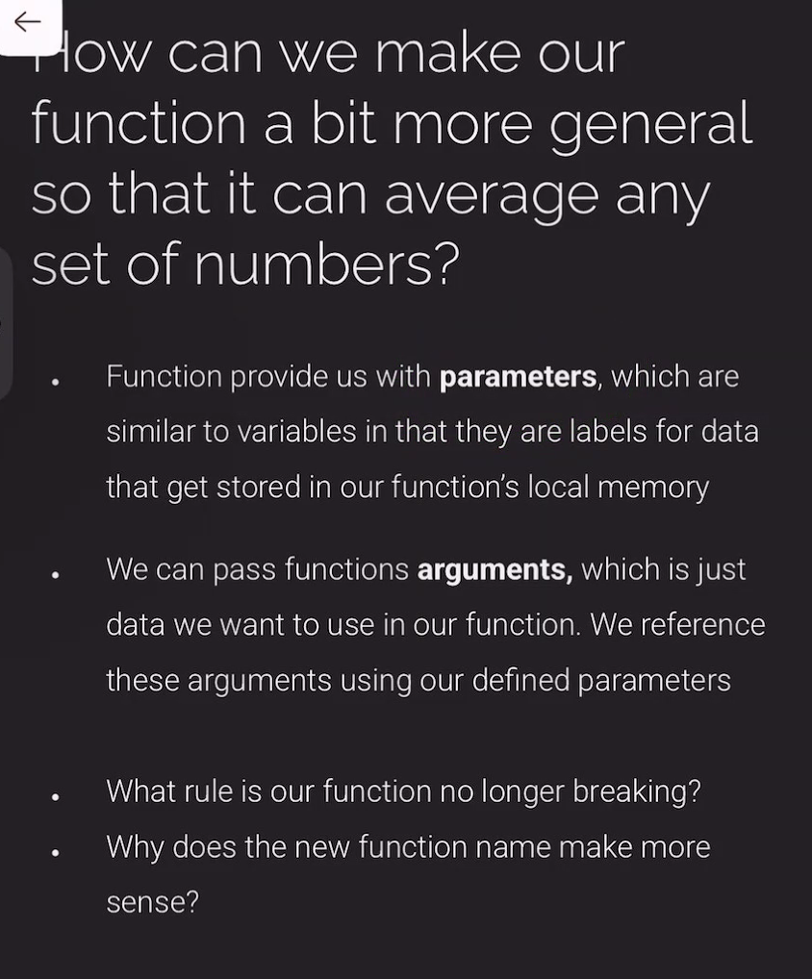

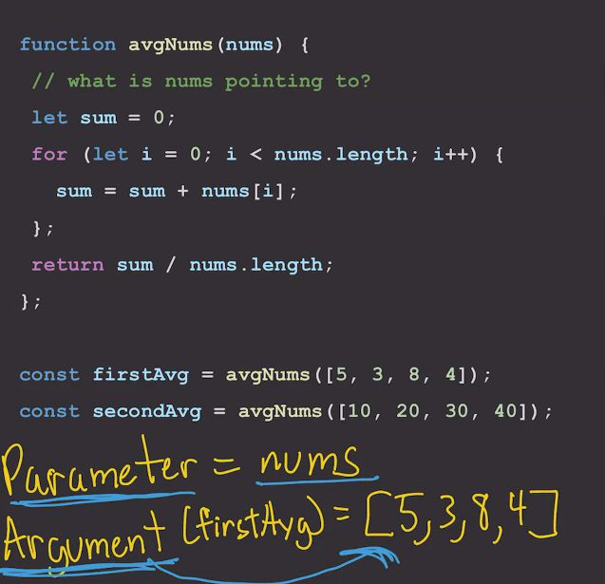

Functions

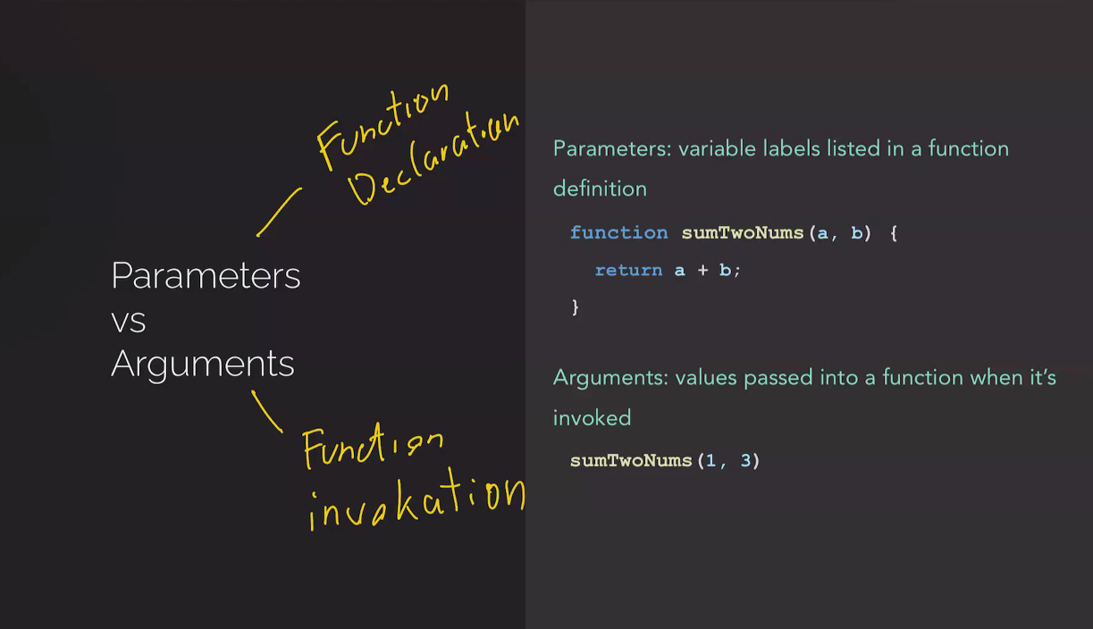

Functions

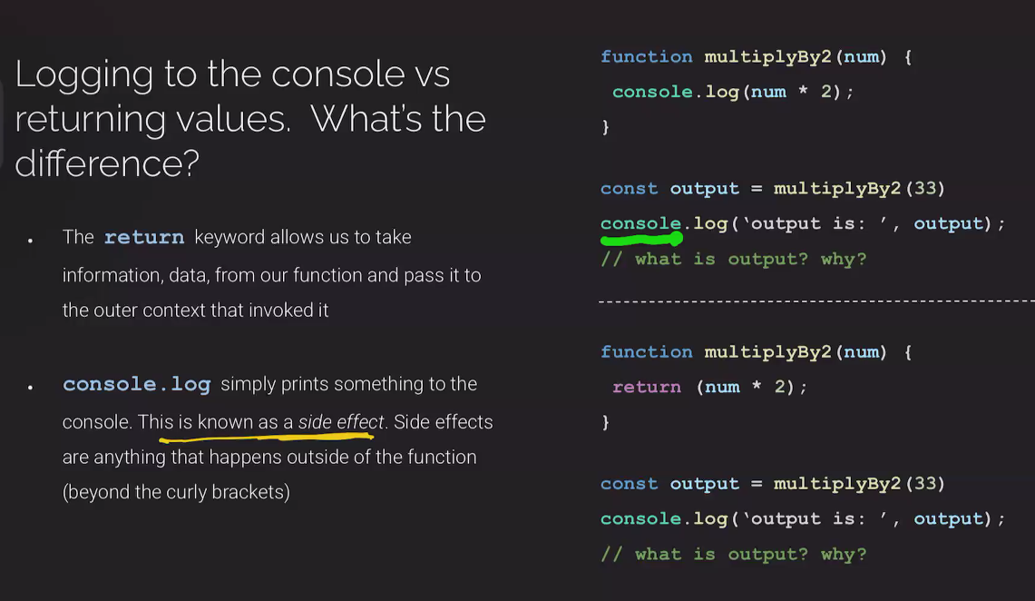

Arrow functions

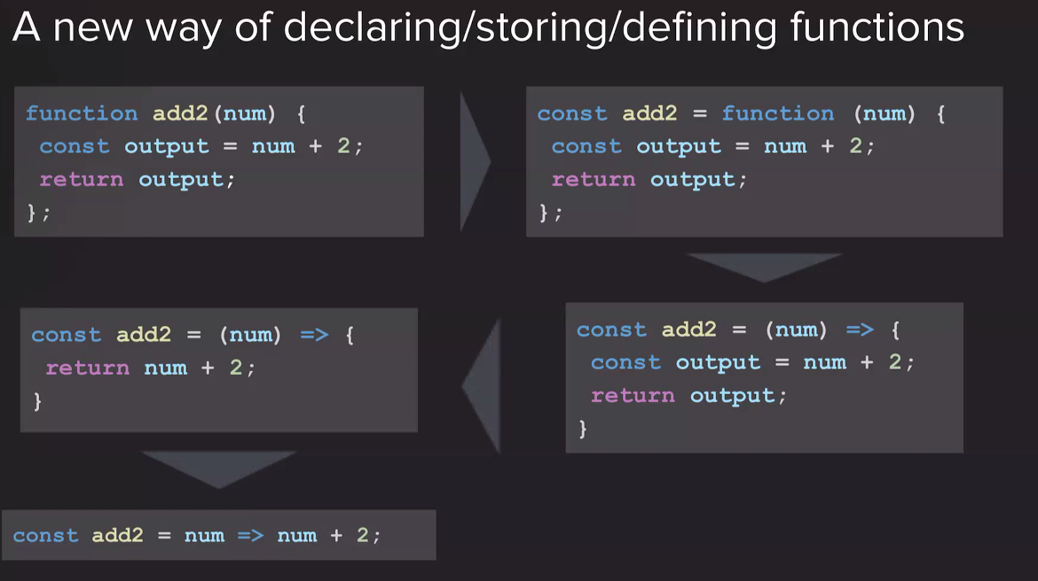

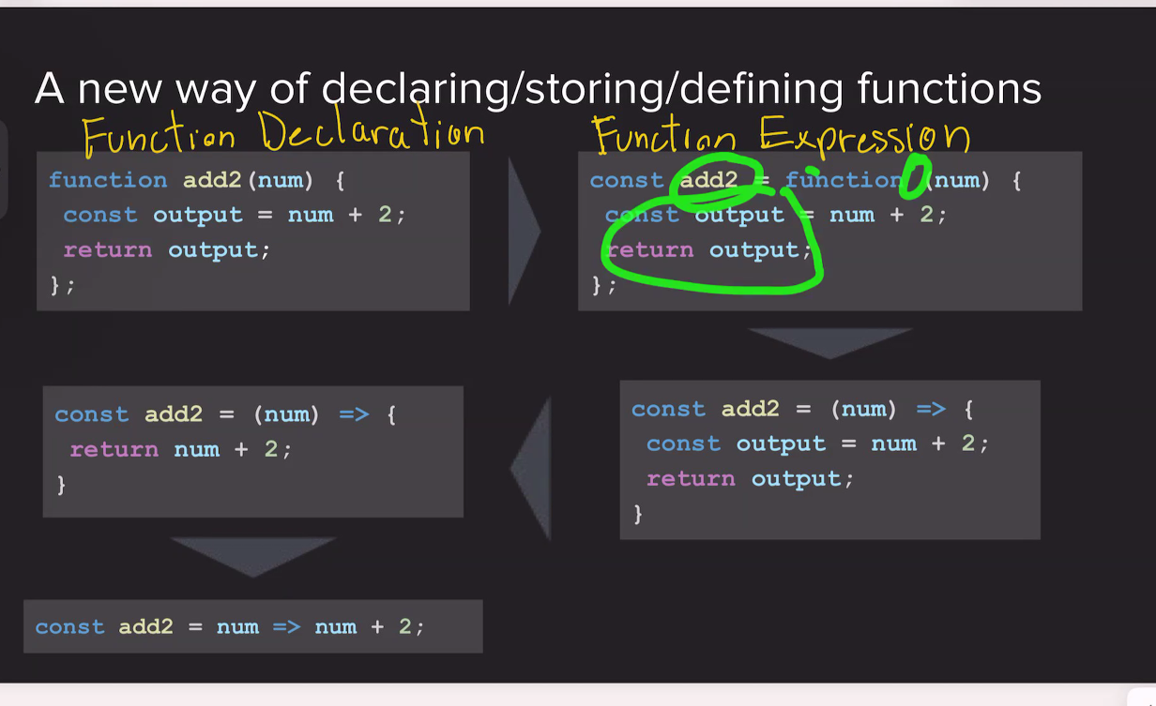

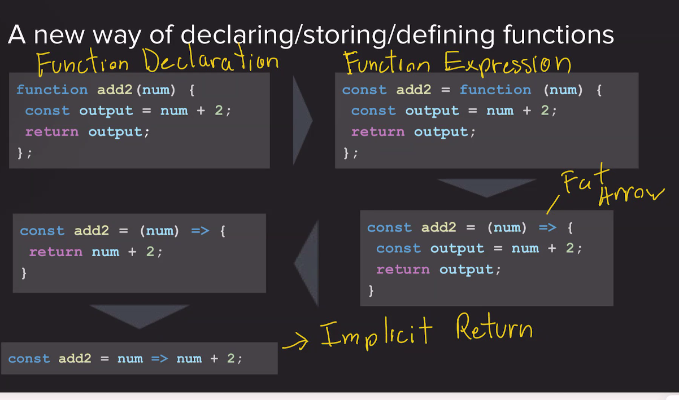

Array Methods

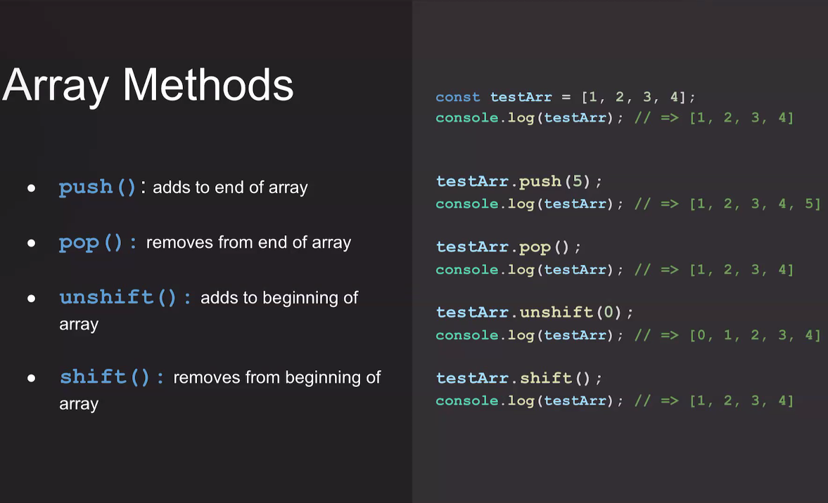

Object

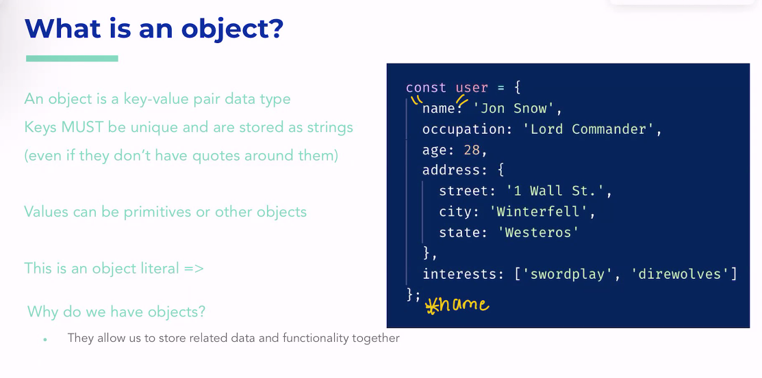

Objects

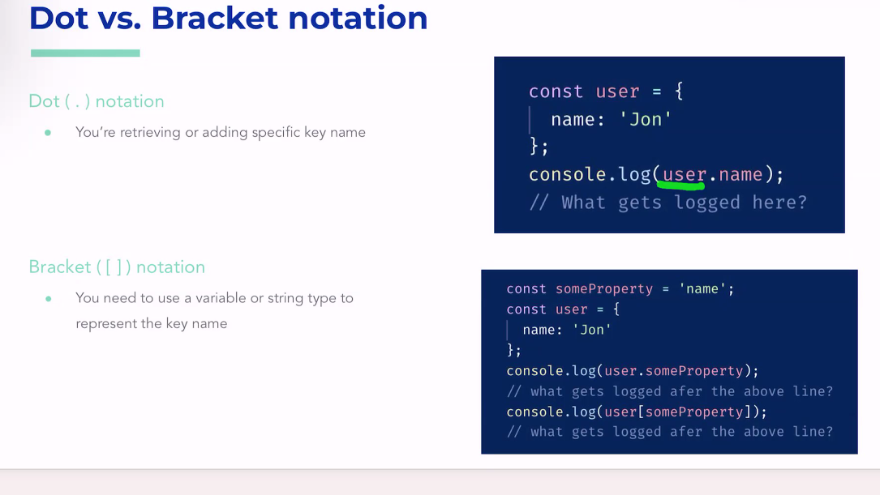

Object methods 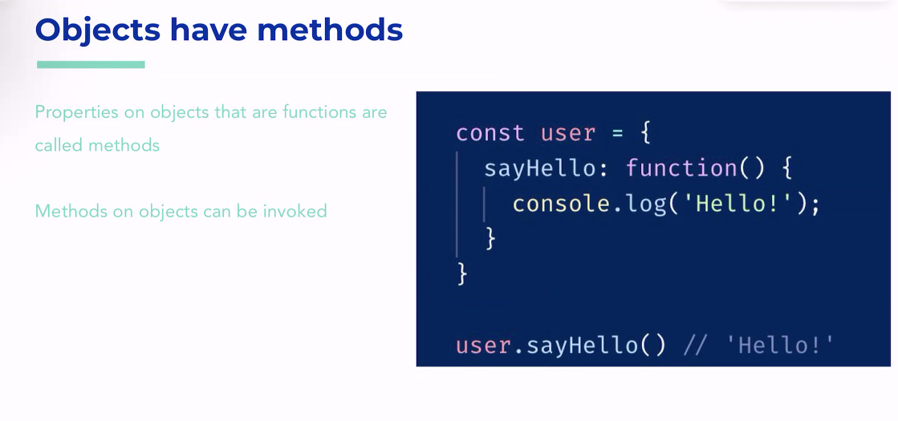

Object this keyword

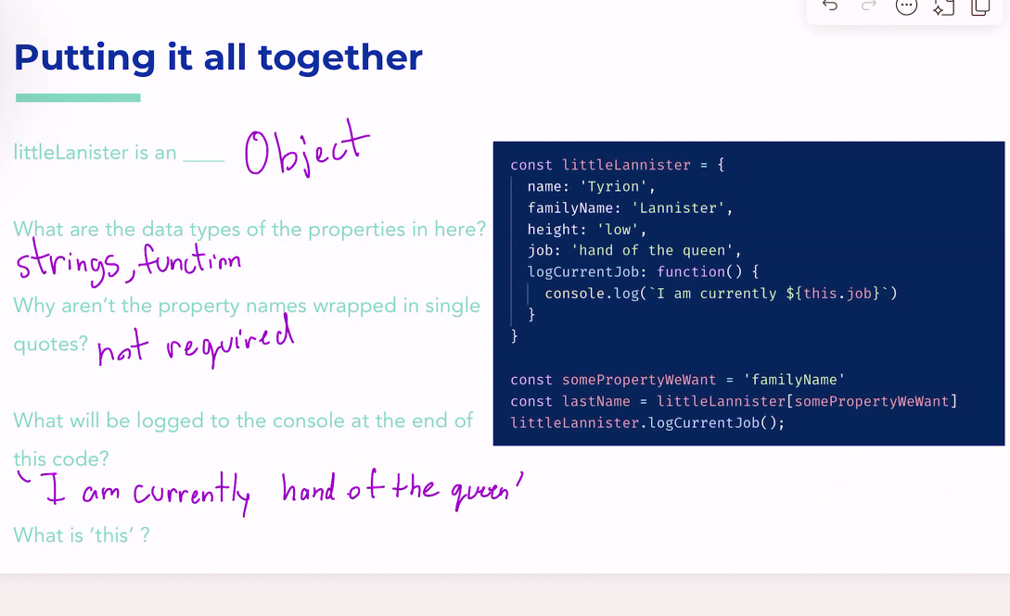

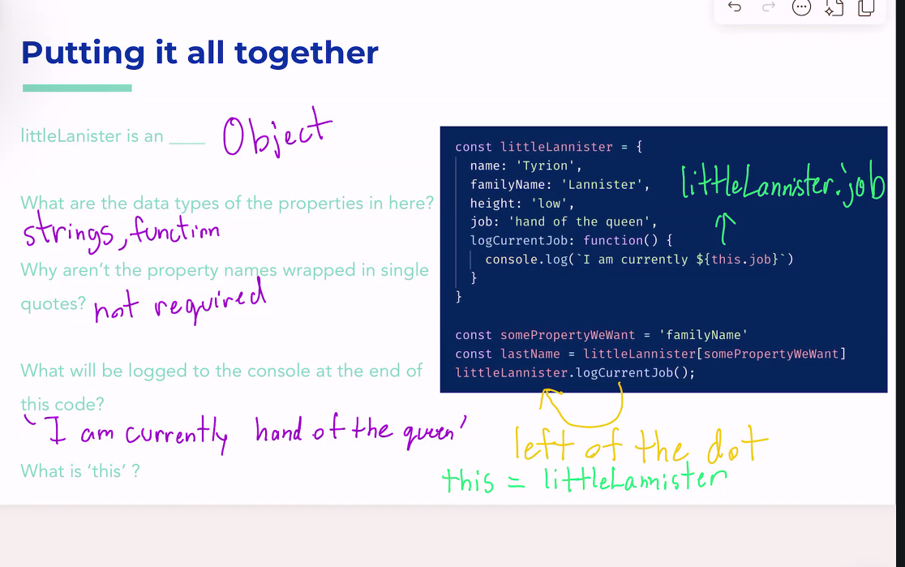

Object .create()

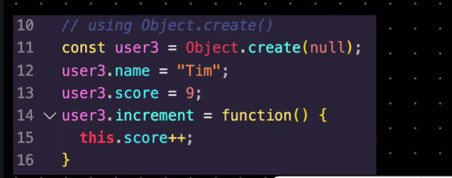

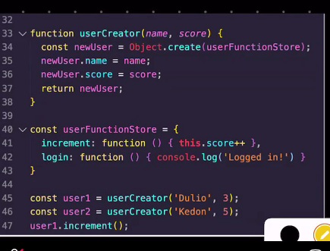

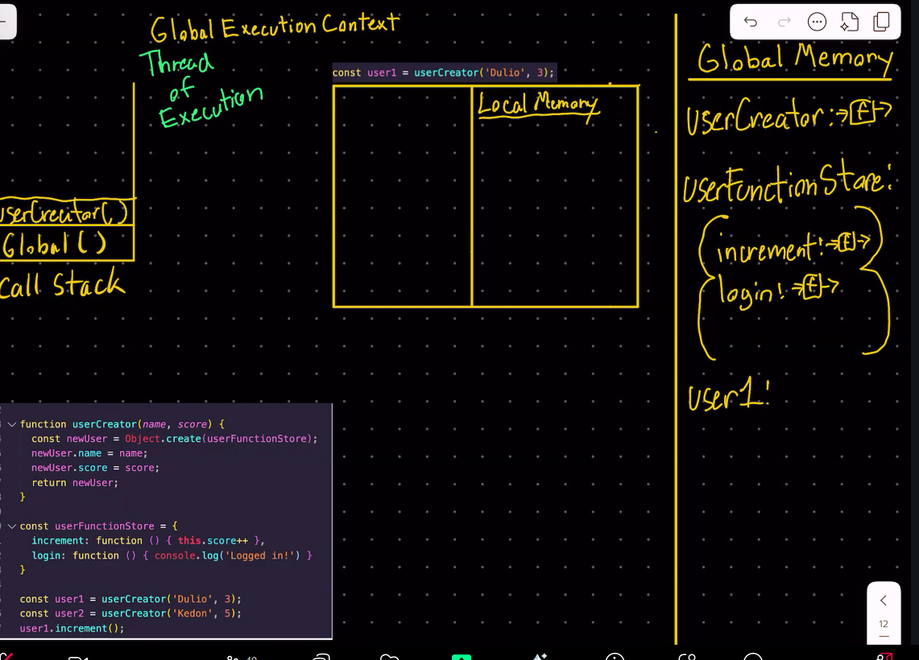

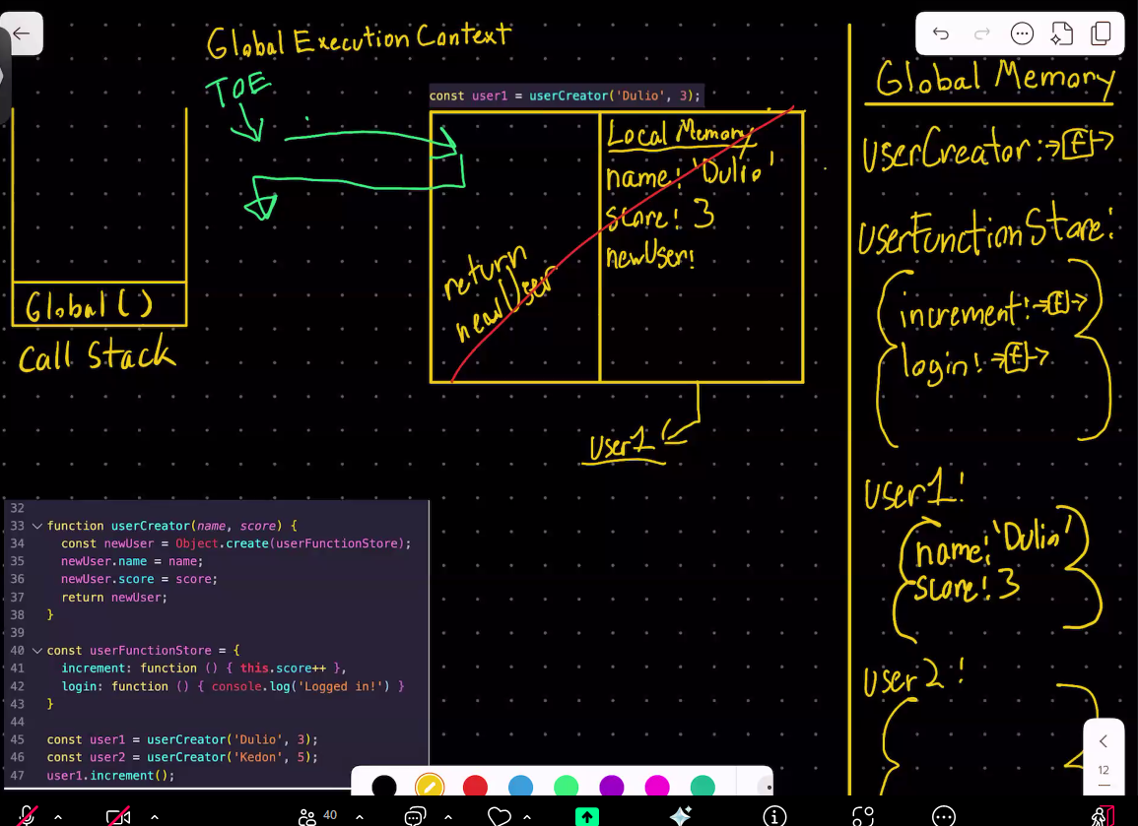

Object chaining, prebuilt properties that exist in every object in javascript

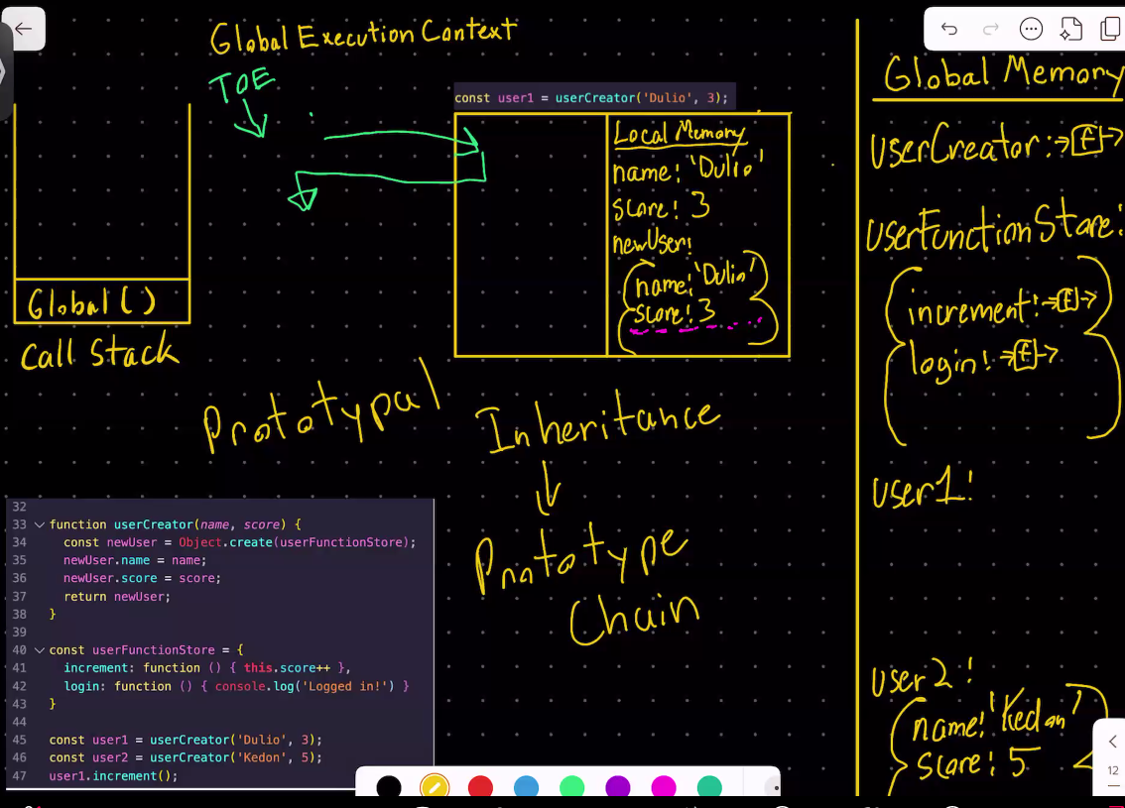

Object inheritance and prototypes

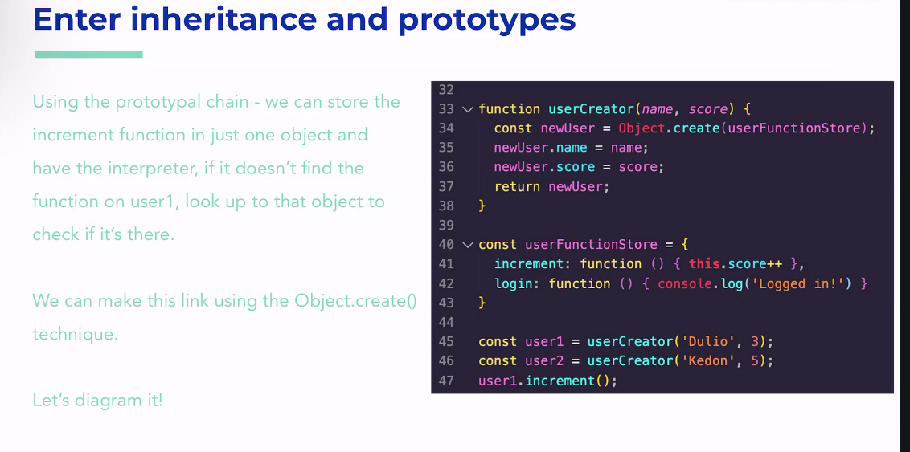

Object inheritance and prototypes

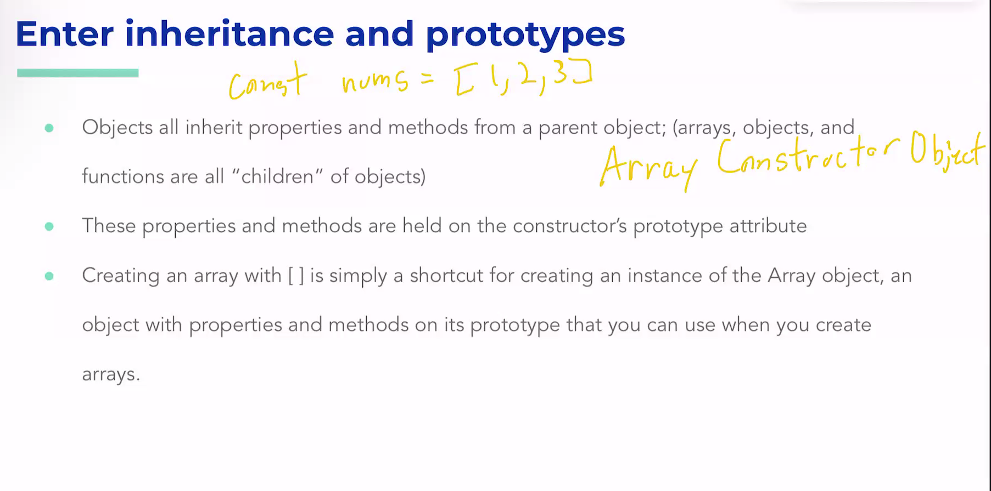

Object javascript objects

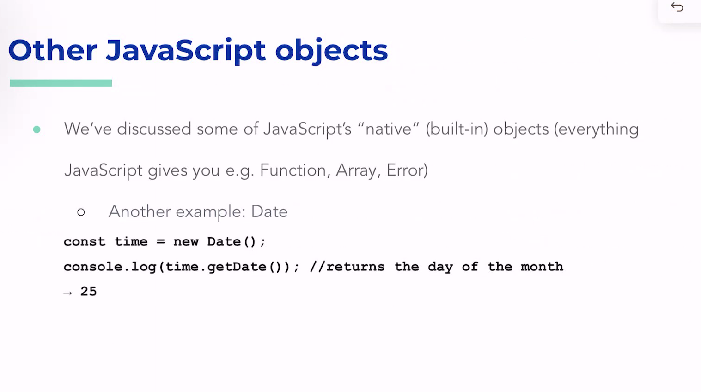

Object “this” keyword in arrow functions

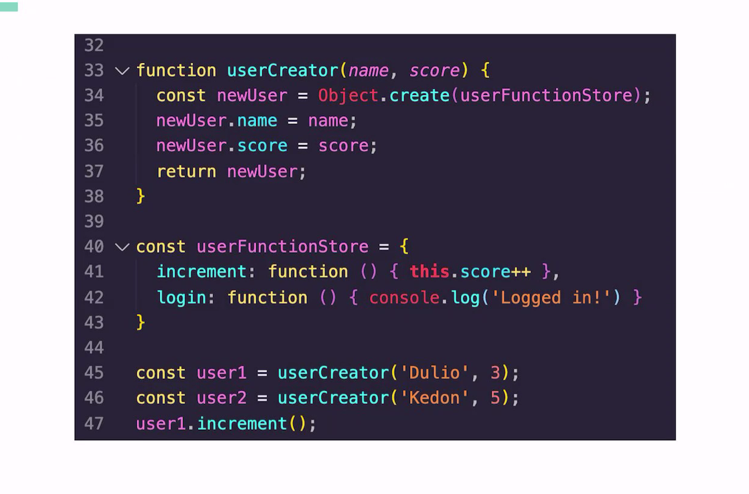

Javascript alert, confirm, notify

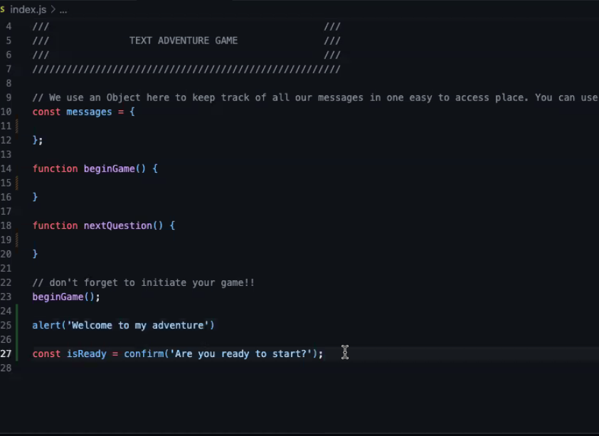

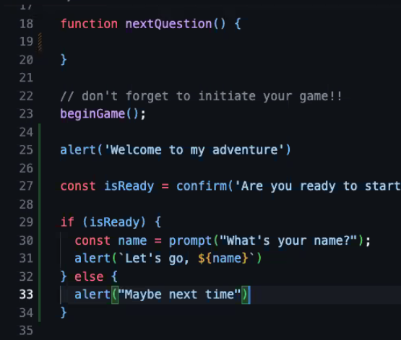

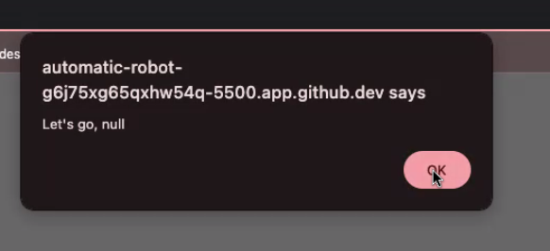

Take the first 20 mins to project plan

1. Start of Story: how will you welcome the player?
2. First Question: What’s the first choice they’ll make?
3. Branching Outcomes: What happens for each answer?
4. Loop or Restart? What happens at the end — do they restart?
5. Variables to Track: Do you want to keep score, name, etc.?